Notification of conversion
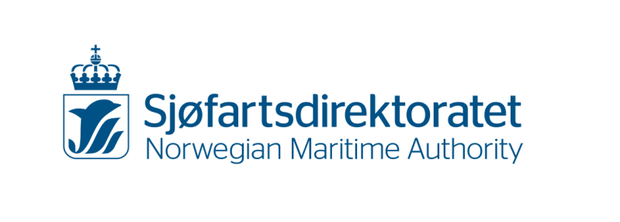
Passenger, cargo and fishing vessel

Information about the vessel before conversion
Name of vessel |  |  | Call sign |  |  | IMO number |  |  |  |  | Hull material
Length |  |  | Gross tonnage |  |  | Draught |  | Is the vessel classed in a recognised classification society?  Yes. Enter name: No, unclassed
The name and address of the shipyard |  |  | Nearest NMA office  (see information on the final page) |  |  |  |  |  | The vessel’s maximum speed
Total propulsion power (kW) |  |  | Total auxiliary machinery (kW) |  |  |  |  |  |  | Total power (kVA/voltage)
Information about the vessel after conversion
The vessel’s overall length after conversion |  |  | Approx. gross tonnage after conversion |  |  |  |  |  |  | Approx. deadweight (tonnes) after conversion
Draught after conversion |  |  | The vessel’s maximum speed after conversion
Total propulsion power (kW) after conversion |  |  | Total auxiliary machinery (kW) after conversion |  |  |  |  |  |  | Total power (kVA/voltage) after conversion
Date of contract |  |  | Planned completion date
Company's contact person |  |  | Phone number |  |  |  | E-mail

Information about certificates
Before conversion: |  |  |  |  | After conversion:
The ship’s main certificate: |  |  |  |  | New main certificate after conversion:
The ship's area of operation: |  |  |  |  | The ship's area of operation after conversion:
Radio coverage for sea area: A1 A2 A3 A4 |  |  |  |  | Radio coverage for sea area: A1 A2 A3 A4
Include a description of the conversion

Any notes, limitations or other particulars

Place and date |  |  |  | Signature company/yard liable

KS-0115 Request for supervision must also be submitted to: post@sdir.no

Submission of form:
At the Norwegian Maritime Authority’s Form Services you may submit the form electronically or by mail.

The form may be submitted as an e-mail attachment to post@sdir.no.
Alternatively, it may be sent by letter to the NMA main office.

Assistance:
If you need more assistance, please contact the Norwegian Maritime Authority. Please remember to state the name/code of the form in your enquiry to make it easier to find the correct person for your questions about the form.

Address to the main office:
Norwegian Maritime Authority
P.O.Box 2222
NO-5509 Haugesund
Norway

E-mail: post@sdir.no
Tel.: +47 52 74 50 00
Fax: +47 52 74 50 01

Visiting addresses to NMA offices:

Office location | Visiting address
Oslo | Strandgata 19, 0152 Oslo
Larvik | Storgata 46, 3256 Larvik
Stavanger | Haakon VII’s gate 8, 4005 Stavanger
Haugesund | Smedasundet 50A, 5528 Haugesund
Kristiansand | Sjølystveien 1, 4610 Kristiansand
Bergen | Møllendalsveien 6, 5900 Bergen
Florø | Hamnegata 3, NO-6900 Florø
Ålesund | Kongensgt. 25, 6002 Ålesund
Kristiansund N | Astrups gate 9, 6509 Kristiansund N
Trondheim | Kongensgate 60, 7012 Trondheim
Sandnessjøen | Torolv Kveldulvsons gate 7, 8006 Sandnessjøen
Bodø | Sjøgata 21, 8006 Bodø
Svolvær | Torget 4, 8300 Svolvær
Harstad | Torvet 7, 9405 Harstad
Hammerfest | Strandgata 58 A, 9600 Hammerfest
Tromsø | Strandveien 106, 9006 Tromsø

